Galt and Blair |  |  |  | 9:00 Walk the Kindness Way, LTC Walk and Roll (B)  10:00 Canada Day Games (B)  11:00 Canada Day Games (G)  2:00 Ice Cream Treats (B/G) | 9:00 Walk the Kindness Way, LTC Walk and Roll (G)  10:00 Beauty Shop(G)  11:15 Physio Fitness (G)  2:00 Beauty Shop (B) | Independent Program Day
Independent Program Day | 9:00 Walk the Kindness Way, LTC Walk and Roll (B)  10:00 Fun with Words (B)  11:00 Fun with Words (G)  2:00 Freshly Squeezed Lemonade (B)  2:00 Freshly Squeezed Lemonade (G)  6:15 Variety Time (G) | 10:00 Horse Shoes in the Courtyard (B)  11:00 Horse Shoes in the Courtyard (G)  1:00 Walk the Kindness Way, LTC Walk and Roll (G)  2:00 Physio Fitness (G)  2:00 Social Art (B)  2:00 One to One Visits (G)  6:15 Variety Time (G) | 10:00 Spic and Span (B)  10:30 Spiritual Refreshment (G)  1:00 Walk the Kindness Way, LTC Walk and Roll (B)  2:00 Baking (G)  2:00 Baking (B)  6:15 Variety Time (G) | 1:00 Walk the Kindness Way, LTC Walk and Roll (G)  2:00 Bingo (B)  3:00 Bingo (G)  6:15 Variety Time (B) | 9:00 Walk the Kindness Way, LTC Walk and Roll (B)  10:00 Beauty Shop (G)  11:15 Physio Fitness (G)  2:00 Beauty Shop (B) | 9:00 Walk the Kindness Way, LTC Walk and Roll (G)  10:00 Java Music Club (B)  2:00 Outdoor Chats (B)  2:00 Outdoor Chats (P)
9:00 Walk the Kindness Way, LTC Walk and Roll (B)  10:00 Active Games (B)  11:00 Active Games (G)  2:00 Ice Cream Cart (G/B) | 9:00 Walk the Kindness  Way, LTC Walk and Roll (G)  10:00 Outdoor Chats in the  Courtyard (B)  11:00 Outdoor Chats in the Courtyard (G)  2:00 Wizard Card Game (B)  3:00 Wizard Card Game (G) | 10:00 Musical Guest (B)  11:00 Musical Guest (G)  1:00 Walk the Kindness Way, LTC Walk and Roll (B)  2:00 Physio Fitness (G)  2:00 Making Hamade Jam (B)  2:00 Sing A Long (G)  6:15 Variety Time (B) | 9:00 Walk the Kindness Way, LTC Walk and Roll (G)  10:00 Summer Painting (B)  10:30 Spiritual Refreshment (G)  12:00 BBQ Dinner  2:00 Summer Craft (B)  2:00 Summer Craft (G)  6:15 Variety Time (B) | 9:00 Walk the Kindness Way, LTC Walk and Roll (B)  10:00 Bingo (B)  11:00 Bingo (G)  2:00 Making Hamade Jam (G) | 9:00 Walk the Kindness Way, LTC Walk and Roll (G)  10:00 Beauty Shop (G)  11:15 Physio Fitness (G)  2:00 Beauty Shop (B) | 9:00 Walk the Kindness Way, LTC Walk and Roll (B)  10:00 Java Music Club (G)  2:00 Outdoor Chats (B)  3:00 Outdoor Chats (G)
9:00 Walk the Kindness Way, LTC Walk and Roll (G)  10:00 Active Games (B)  11:00 Active Games (G)  2:00 Ice Cream Cart (G/B) | 10:00 Iced Coffee In the  Courtyard (B)  11:00 Iced Coffee in the  Courtyard (G)  1:00 Walk the Kindness Way, LTC Walk and Roll (B)  2:00 Baking (G)  2:00 Baking (B)  6:15 Variety Time (G) | 10:00 Beach Ball Bash (B)  11:00 Beach Ball Bash (G)  1:00 Walk the Kindness Way, LTC Walk and Roll (G)  2:00 Physio Fitness (G)  2:00 Baby Bath Time and Favorite Nursey Rhymes (B)  2:00 One to One Visits (G)  6:15 Variety Time (G) | 10:30 Spiritual Refreshment (G)  1:00 Walk the Kindness Way LTC, Walk and Roll (B)  2:00 Wellness Group (B)  3:00 Wellness Group (G)  6:15 Variety Time (B) | 1:00 Walk the Kindness Way, LTC Walk and Roll (G)  2:00 Bingo (B)  3:00 Bingo (G)  6:15 Variety Time (B) | 9:00 Walk the Kindness Way, LTC Walk and Roll (B)  10:00 Beauty Shop (G)  11:15 Physio Fitness (G)  2:00 Beauty Shop (B) | 9:00 Walk the Kindness Way, LTC Walk and Roll (G)  10:00 Java Music Club (B)  2:00 Outdoor Chats (B)  3:00 Outdoor Chats (G)
9:00 Walk the Kindness Way, LTC Walk and Roll (B)  10:00 Active Games (B)  11:00 Active Games (G)  2:00 Ice Cream Cart (G/B) | 9:00 Walk the Kindness  Way, LTC Walk and Roll (G)  10:00 Spelling Bee (B)  11:00 Spelling Bee (G)  2:00 Table Top Games (B)  3:00 Table Top Games (G) | 10:00 Fresh Local Fruit Salad (G)  1:00 Walk the Kindness Way, LTC Walk and Roll (B)  2:00 Physio Fitness (G)  2:00 Fresh Local Fruit Salad Prep (B)  2:00 One to One (G)  6:15 Variety Time (B) | 9:00 Walk the Kindness Way, LTC Walk and Roll (G)  10:00 Summer Crafts (B)  10:30 Spiritual Refreshment (G)  2:00 Fresh Flower Arrangements (B)  2:00 Fresh Flower Arrangements (G)  6:15 Variety Time (G) | 10:00 Bingo (B)  11:00 Bingo (G)  1:00 Walk the Kindness Way, LTC Walk and Roll (B)  2:00 Summer Craft (G) | 9:00 Walk the Kindness Way, LTC Walk and Roll (G)  10:00 Beauty Shop (G)  11:15 Physio Fitness (G)  2:00 Beauty Shop (B) | 9:00 Walk the Kindness Way, LTC Walk and Roll (B)  10:00 Java Music Club (G)  2:00 Outdoor Chats (B)  3:00 Outdoor Chats (G)
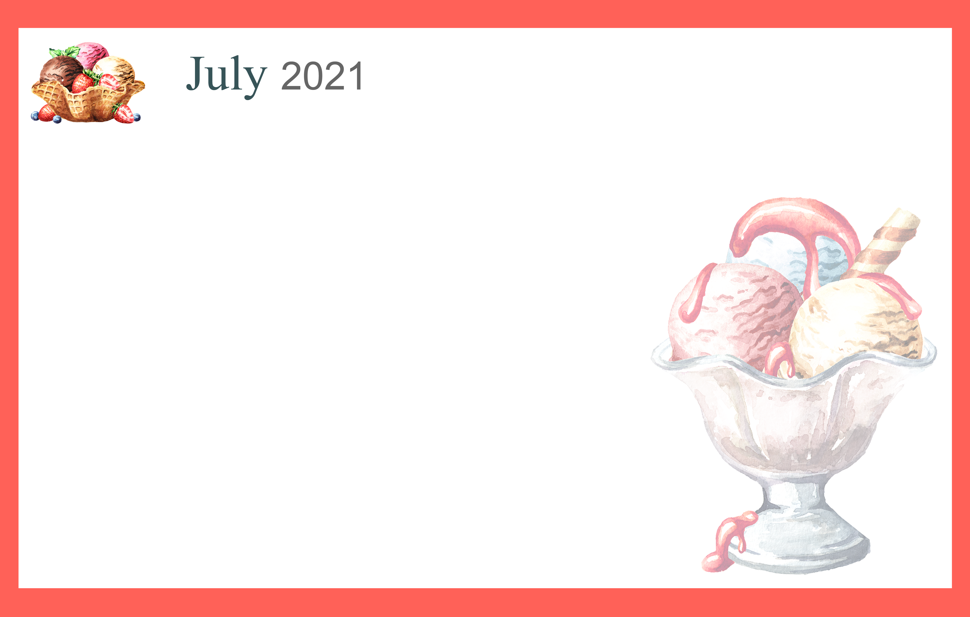
Check program boards daily for the most up to date information.
Sunday | Monday | Tuesday | Wednesday | Thursday | Friday | Saturday
 |  |  |  | 1  Canada Day | 2 | 3
4  Independence Day (US) | 5 | 6 | 7 | 8 | 9 | 10
11 | 12 | 13 | 14 | 15 | 16 | 17
18 | 19 | 20 | 21 | 22 | 23 | 24
25 | 26 | 27 | 28 | 29 | 30 | 31

