Draft Key Messages – My Community, My Home
Parkwood Capital Campaign 2021 – 2026

The need
There is a chronic shortage of elder-friendly affordable housing, especially for seniors of modest and middle income means, in the Region of Waterloo.
The Region has confirmed the creation of affordable housing as its top priority. More than 25 per cent of people living in Waterloo Region are 55 years of age and older and many of them do not have the means to retire in a safe, comfortable home. There is an urgent need for affordable housing, right now, for existing and incoming older adults.
Parkwood is poised to help bridge the gap across all income levels.

The opportunity
We have a proven elder-friendly, affordable home and community campus model that can be expanded to Parkwood. Our beautiful eight-acre site in Waterloo is shovel-ready.
Fairview Seniors Community has worked with Waterloo Region for decades to provide affordable housing for older adults of modest and middle income means in Cambridge. We understand how to manage and sustain this model. We are a trusted partner.
Parkwood Seniors Community also has nearly 60 years of experience in providing homes and access to amenities that enrich life in a welcoming community, thanks in large part to the generous support of donors, many from our beloved Mennonite community.
When considering the opportunity to grow, we sought a project that would align with our values. Reserving one-third of the apartments for affordable housing meets this key objective. Through careful planning with the Region, Parkwood can build apartments that offer older adults of modest to middle means a wonderful retirement opportunity.
At the same time, we know that there are those of comfortable means who prefer to live modestly, in alignment with their values and the faith-based values reflected at Parkwood.
When our new building is completed, we will welcome older adults who wish to embrace a unique culture of kindness, a warm community and an opportunity to live on a vibrant, active campus, regardless of their financial means.

The funding
We will demonstrate our confidence in this project with a $1 million gift from our reserve funds which we have accrued through careful financial management.
The total cost of the project is $30 million, with $20 million funded and sustained through existing channels, including a CMHC mortgage, and $5 million covering the cost of the land, which Parkwood will provide on its existing site. This leaves $5 million – less a $1 million gift from Parkwood’s reserves – to be raised to ensure we can build and finance the one-third affordable housing portion in a responsible, sustainable model.
We hope to educate, inspire and mobilize the community to partner with us to raise the remaining $4 million through gifts of any size. A gift can be made with one single donation or pledged to fulfill your giving aspirations and budget, monthly or annually, over five years.

Why Parkwood?
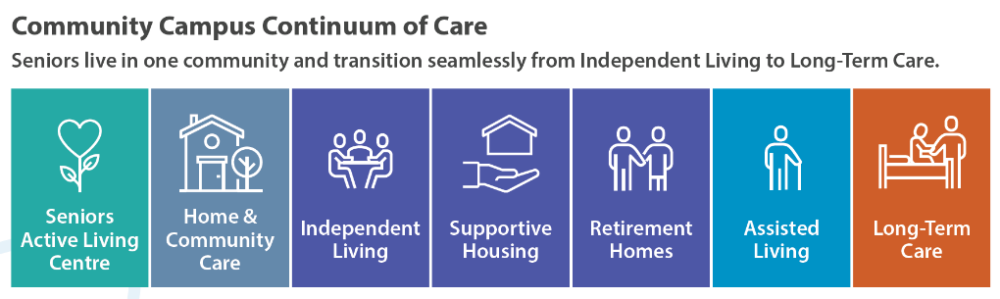
Parkwood offers a home and a community, on one vibrant, active campus.
+
Supportive Living
Health and Wellness Centre
Affordable Housing

Parkwood Seniors Community is a not-for-profit campus that offers a range of living options, from independent living with Home and Community care to long-term care. What makes Parkwood special is the attention paid to creating amenities and spaces that encourage health, wellness, kindness and ensuring everyone has an equal seat at our community table.
We hold ourselves accountable to our Mennonite faith-based values, which have provided guidance and sustained our unique community for more than 55 years. Those values are interwoven throughout our Welcome Statement, Kindness Initiative and Strategic Plan, and are the foundation and springboard of our commitment to Build a Community for All. This is our niche and our reason for being.
Our values are reflected in our logo, which suggests that residents are able to continue to grow (leaves) within a secure environment (circle) and a caring community (heart). That is who we are.

You are welcome here
As a community founded in God’s love for all and grounded in faith, each person is valued and respected. We honour the spiritual dimension of the human experience and believe that, with love, the extraordinary is possible.
While we share similar organizations’ goals to create a surplus, what differentiates us is the way our faith-based values guide us on where we reinvest these funds to fulfill our mission.
The new apartments and suites are an example of the intersection of our values and the urgent need for affordable housing so that those of all means - modest, middle and comfortable – might retire with dignity.
At Parkwood, this means more than a home of one’s own. It also means access to the amenities, services and supports that help to meet the changing physical, spiritual, social and emotional needs of older adults, including the need to live a meaningful life in a safe, welcoming community – something we have all come to value even more, following the pandemic.
We all know someone who needs and deserves the opportunity to enjoy a fulfilling retirement. Imagine how your thoughtful consideration of a gift could change an older adult’s life. Imagine them hearing…
Welcome to Parkwood! This is your home. This is your community. Everyone has an equal place at the table.

What makes us community?
We share core values of faith and community. These faith-based values are the foundation and springboard that have supported us to build two Campuses of Care for those who require assistance with daily living.
By strengthening our organizations in the face of many external pressures, we ensure that, together, we can continue to sustain our unique faith and values. This is what truly differentiates us.
At Parkwood and Fairview, the strength of, and commitment to, our faith-based values is embedded in everything we do. It shines through our logo, whose circle represents community, and three elements represent mind, body and spirit. Our values are also expressed through our operating principles, human resources policies, kindness initiative, strategic plan, and internal and community relationships.
While we share similar organizations’ goals to create a surplus, what differentiates us is how we build upon our faith-based values to determine where we reinvest these funds to fulfill our mission. For example, we have built supportive housing and independent living at fair market value. Our villas were built and sold at cost with a continued philosophy to resell at a reasonable cost. We have invested in a vibrant Seniors Active Living Centre, a warm and welcoming congregate dining area, and have a Director of Spiritual Care on staff.
Our committed congregations support our meaningful work. Every day, we live our values to enhance our services and spaces to continuously build and support our community, in congruence with our beliefs.
This is who we are, as Mennonites, and how we have built our organizations. We share the same purpose and commitment to living our values. With gratitude and humility, we see that many people, of Mennonite and other faiths, respect us and our reputations, to the extent that people from 19 different church denominations and/or faiths have chosen to make Fairview or Parkwood their home.
Today, we can reach deeply into our faith and values and build upon our willingness to work together to meet the challenges and changes we now face; at the same time, we will prepare our organizations to meet the future from an even greater position of strength.
Together, we can demonstrate what it means to be a faith-based organization in the 21st century, as we continue to provide affordable, not-for-profit services to build a community for all.

